**Environment Setup**

**Create a Flask Project**

|  |  |
| --- | --- |
| Team ID | PNT2022YMID09679 |
| Project Name | Nutrition Assistant Application |

**Code :**

from flask import Flask

app = Flask(__name__)

@app.route("/")

def hello(): return "Hello, World!"

**Terminal :**

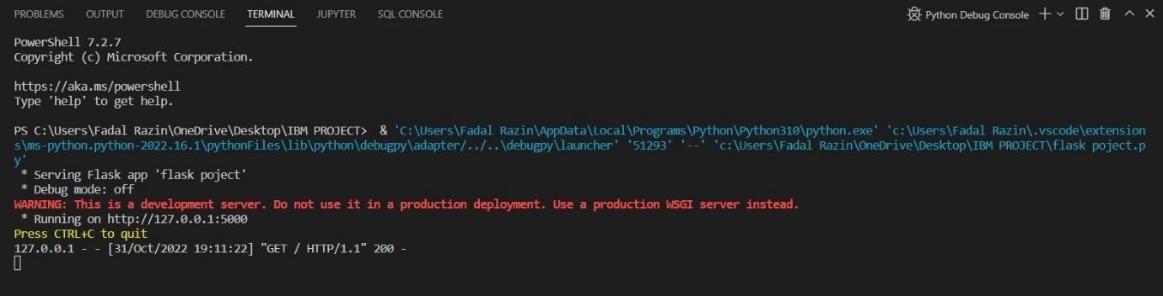

**Page :**

